**DOKUZ EYLUL UNIVERSITY**

**ENGINEERING FACULTY**

**DEPARTMENT OF COMPUTER ENGINEERING**

**CME1252 PROJECT BASED LEARNING – II**

**FINAL REPORT**

**PROJECT – III**

**CHAIN**

**by**

**Kerem Kalıntaş**

**Ramazan Denli**

**Ramazan Fidan**

**Yunus Emre Taşbaşı**

**Lecturers**

**Associate Professor Semih Utku**

**Onur Can Doğanlar**

**29.05.2023**

# CHAPTER ONE

PROGRESS DESCRIPTION

Our "Chain" number game project has made significant progress:

* Game structure: 10x16 board with numbers and plus signs.
* Players construct chains by inserting plus signs.
* Chain rules: adjacent squares must differ by 1, minimum chain length is 4.
* Game flow: Players validate chains by pressing enter, incorrect chains lead to game over.
* Valid chains are added to the table, removed from the board, and scored.
* Game termination with an option to exit.
* High score table displayed at the end.

We have implemented the core functionalities, and further tasks include UI refinement and adding the high score table. The project is on track for a fun and engaging gaming experience.

# CHAPTER TWO

TASK SUMMARY

## Completed Tasks

Ramazan Denli: Design of classes, data structures. Screen. Board initialization. Scoring. Updating board.Table.

Yunus Emre Taşbaşı : Highscore table, calculating the score

Kerem Kalıntaş: I wrote the Player class, game initialization, main game loop, game menu and also chain construction.

## Incomplete Tasks: Reasons and Explanations

Ramazan Denli:None.

Yunus Emre Taşbaşı : None.

Kerem Kalıntaş: I dont have any incompleted tasks.

## Additional Improvements ~~to the Project~~

Ramazan Denli:None.

Yunus Emre Taşbaşı : None.

Kerem Kalıntaş: Reseting the game when user pressed R key while playing the game. And showing chain erorr reason on game over.

# CHAPTER THREE

EXPLANATION of algorıthms

## Screenshots

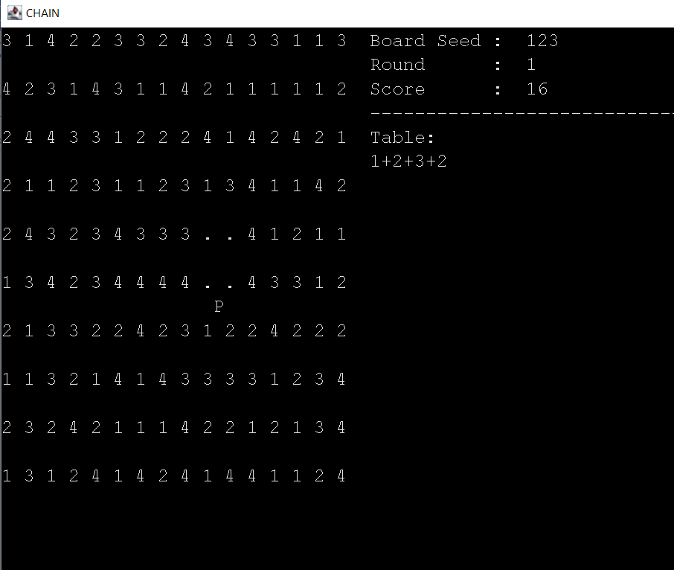

## Functions

public void initialize()

public boolean run()

public void gameMenu()

private void gameOver()

private void clearScreen()

private void setCursorPosition(int x, int y)

public void printSquare(char square, int x, int y)

private void printScreen()

private void constructChain()

private void addToTable()

## Algorithms and Solution Strategies

Ramazan Denli: In the process of placing numbers, I traversed the previously created array called "board" and assigned a random number between 1 and 4 to each element. To display the screen, I created a function named "printScreen" and printed each element of the "board" array by traversing it. To display the menu, I used the "console.getTextWindow.setCursorPosition()" function. For calculating the score, I created a function in the "SingleLinkedList" class that returns the square of the size. To print the chains after controlling the chain in the function "constructChain()", I inserted the numbers into a multilinkedlist named "table" for the first chainpiece, according to the next chainpiece. For the other chainpieces, I inserted numbers into the list that are different from the last number inserted into the list. Finally, I printed the chain with the help of the "display()" function in the multilinkedlist.

Yunus Emre Taşbaşı : In calculating the score of player i multiplied chain size by itself. I used doubly linked list to do highscore table. To put scores to the table i added 2 exceptions to add highest and lowest score. On other scores i traversed in table and i put it between 2 scores. I added a display method to display all scores at ending.

Kerem Kalıntaş: I used variables for storing the start and end positions of the chain. And checked the players old position and inserted the chain pieces based on those variables. After inserting the new chain, chain start and end variables are updated for getting correct positions in the next insertion.

# CHAPTER FOUR

PROBLEMS ENCOUNTERED

Ramazan Denli: During the process of constructing the chain, I encountered some problems, but Kerem managed to overcome them.

Yunus Emre Taşbaşı : It was getting error when highest and lowest score. I made an exceptions for them.

Kerem Kalıntaş: I had hard time figuring out how to disallow user to place chain pieces on chains middle points. I solved this problem with storing the start and end of the chain. This way i could check if the new chain piece is can be placed.

# CHAPTER FIVE

conclusıon

In conclusion, our group coding project has been a rewarding journey of learning, collaboration, and achievement. Through teamwork, we overcame challenges, implemented innovative solutions, and created a high-quality final product. We developed technical skills, embraced adaptability, and benefited from effective project management. This experience has enriched our knowledge and abilities, fostering growth in problem-solving, communication, and teamwork. We are proud of our accomplishments and excited to apply our newfound expertise in future projects.

REFERENCES

**AppendIx A**

Poster/Web page of the Project

*(Give Picture Of Poster Or Some Key Screens From Web Page.)*

**AppendIx B**

Code of the Project

*(Give clear, indented, fully commented code of your project. Give the most important code parts of your project.)*